Lab – Introduction to Cisco Webex Teams and Cisco Webex Teams for Developers (Instructor Version)

In this lab, students will verify they have a Webex Teams account, log into Webex Teams and become familiar with the basics of using Webex Teams including: creating a room, adding users to the room, sending a message to a room/user, and deleting a message to room/user. They will also use Cisco Webex Teams for Developers to get their Token and become familiar with the API Reference in order to make Webex Teams API calls.

1. Objectives

* Using the Cisco Webex Teams Application
* Using Cisco Webex Teams for Developers

1. Background / Scenario

Cisco Webex Teams is a complete cloud-based collaboration suite for business. Cisco Webex Teams provides collaborative spaces that allow people to meet individually or in teams. In Part 1 of this lab, you will become familiar with the basics of using Cisco Webex Teams. In Part 2, you will work with Cisco Webex Teams for Developers, a web site that makes it easy to use the Cisco Webex Teams RESTful APIs. You will learn how to obtain your Cisco Webex Teams Access Token, which will be used in later labs.

1. Required Resources

* Cisco Webex Teams account
* Cisco Webex Teams desktop application

**Note**: To protect application environments like Webex Teams from bots or malicious access attempts, most open APIs rate limit availability. If you make a large number of the same API calls, your API call may be blocked for a specific amount of time. The timeout is usually less than 5 minutes.

1. Using the Cisco Webex Teams Application
   * 1. Create/Verify your Cisco Webex Teams account.

**Note**: As you work through this lab, there may be places on the Internet where you may see either Cisco Spark or Cisco Webex Teams. These terms may be used interchangeably but are referring to the same product.

* + - 1. Verify your Cisco Webex Teams account by logging into Cisco Webex Teams.
      2. If you are new to Cisco Webex Teams and need to create a Cisco Webex Teams account, go to: [https://www.Webex.com/products/teams/index.html](https://www.webex.com/products/teams/index.html) and download the client.

For more information about Cisco Webex Teams:

* Website: [https://www.Webex.com/products/teams/index.html](https://www.webex.com/products/teams/index.html)
* Video: <https://www.youtube.com/watch?v=OavRKkN8ir4>
  + 1. Navigate the Cisco Webex Teams GUI.
       1. Explore the Cisco Webex Teams application.

[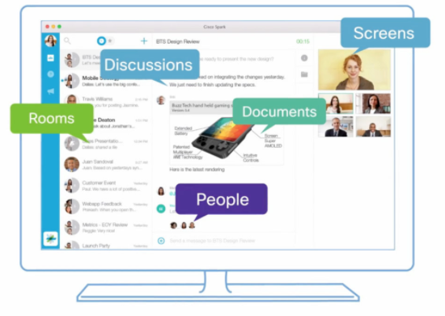](https://www.cisco.com/c/sk_sk/solutions/spark/index.html#~stickynav=1)

* + - 1. In the upper-left, click the circle with your initials, then **Profile**, and add a photo of yourself.
    1. Add people to Cisco Webex Teams.
       1. To add an individual to your Webex Teams People, in the **All** menu click the **+** button to invite people to start a new conversation.

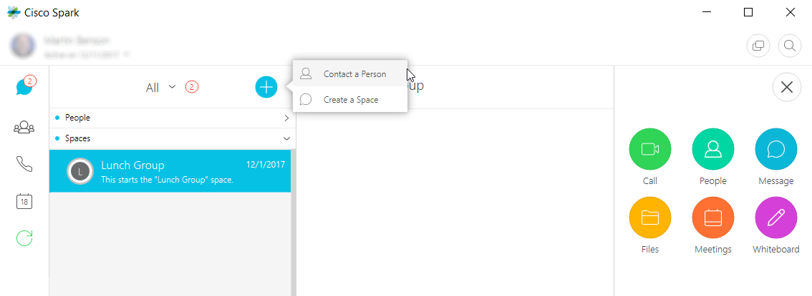

* + - 1. For demonstration purposes, you can use these two email addresses:

[sqtest-ciscospark-travis@squared.example.com](mailto:sqtest-ciscospark-travis@squared.example.com)

and

<sqtest-ciscospark-sheyda@squared.example.com>

* + - 1. Add one or more people from the class to your Webex Teams People.
    1. Add a Space to Cisco Webex Teams.
       1. To create a new Webex Teams room, click the **+** button again and choose **Create a Space**.
       2. Enter a name for the new space and click **Create**.
    2. Add people to a Cisco Webex Teams Space.
       1. To add people to existing rooms, select your Webex Teams room under **Spaces**.
       2. Go to the activity menu (square of dots in upper right) and choose **People**.
       3. Click **Add people** and use the search feature to find and add several people to your Webex Teams room.

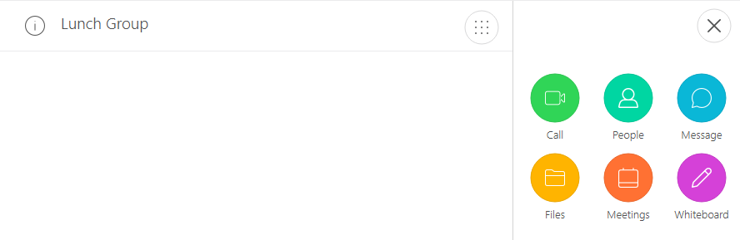

* + 1. Send a message to People and to a Space.
       1. To send a message to someone, you can either send the message directly using (Webex Teams People) or to a group of people who are members of a Webex Teams room (Webex Teams Spaces).

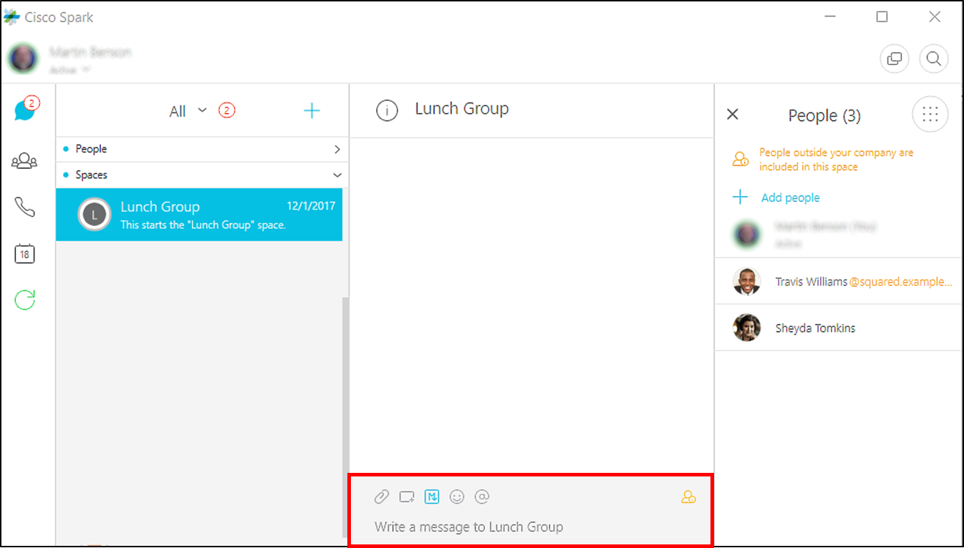

* + - 1. Send two or three messages to each of the rooms you created.
      2. To delete a message, select the specific message and then click the circled-X to the right of the message. You will then be asked to confirm that you wish to delete the message. Be sure to leave several messages in your rooms.

1. Using Cisco Webex Teams for Developers
   * 1. Login to Cisco Webex Teams for Developers.

Cisco Webex Teams for Developers allows you to embed Cisco Webex Teams with other applications, and to extend your Webex Teams experience in other ways.

You will use the Cisco Webex Teams for Developers web site to familiarize yourself with the use of Cisco Webex Teams APIs. Go to the Cisco Webex Teams for Developers web site to obtain your access token. The access token is required for authentication when using Cisco Webex Teams APIs.

* + - 1. Go to: [https://developer.Webex.com/](https://developer.webex.com/)
      2. Login with your email address and password.
    1. Investigate the Cisco Webex Teams for Developers API Reference.
       1. Select **Docs** to access Cisco Webex Teams API documentation.
       2. To see the documentation for Cisco Webex Teams API endpoints, click the down-arrow next to **WEBEX TEAM API**.

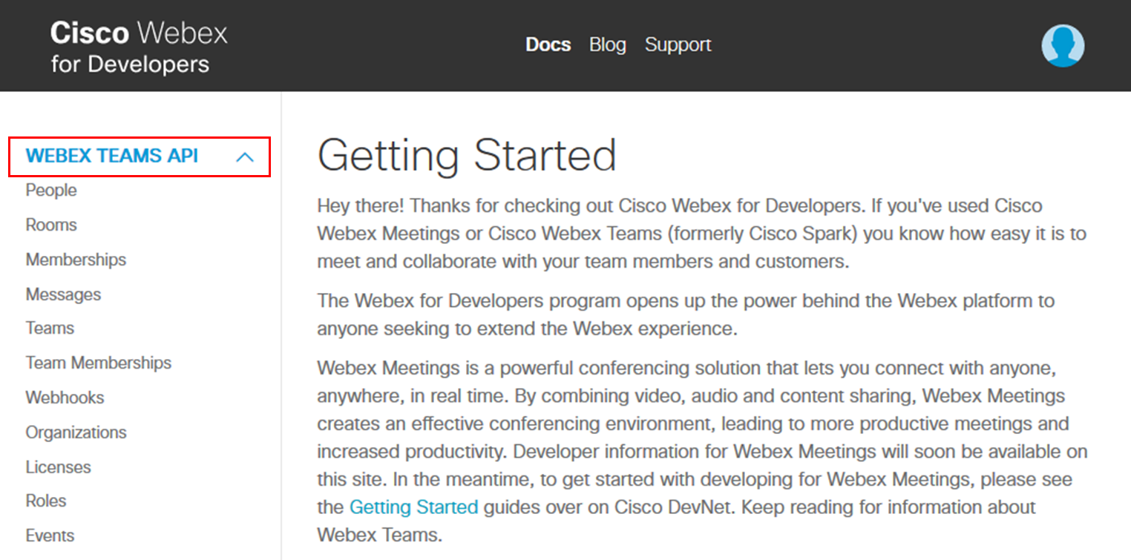

* + - 1. Explore some of the various sections including **People**, **Rooms**, **Memberships** and **Messages**. These will be used in later labs.

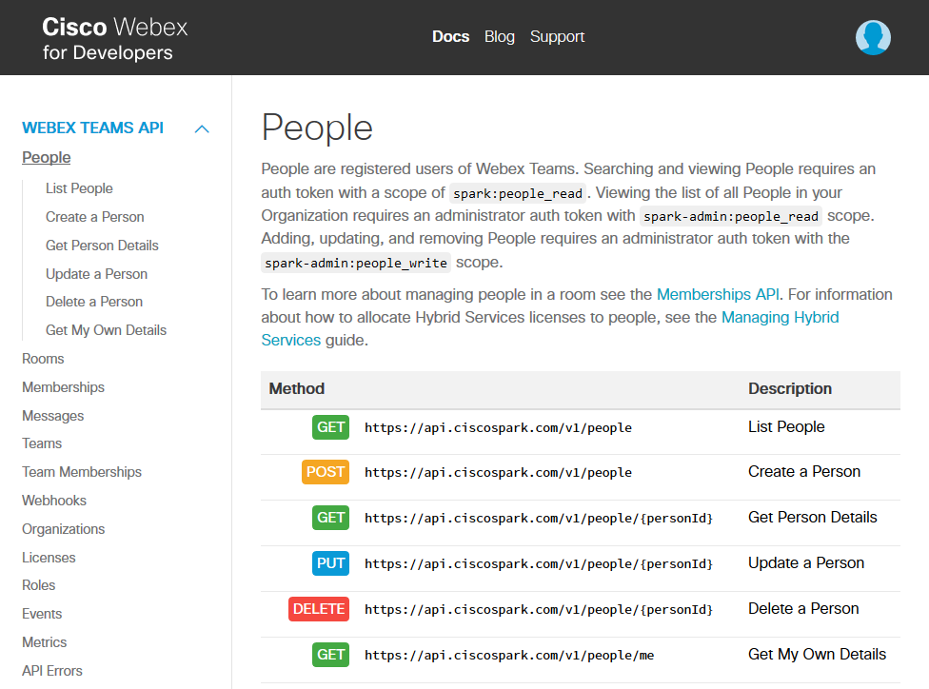

* + 1. Get your Cisco Webex Teams for Developers access token.

In the labs that follow, you need to use your Cisco Webex Teams access token.

* + - 1. To get your access token, click **Docs**.
      2. Scroll down the Docs page and **Copy** the Access Token in the Authentication section.
      3. Your access token will be copied to your clipboard. The token can then be pasted into the appropriate application or program.

